Technical Proposal
Website Development Website Development for Pothikreet Bidyut Ltd.
Prepared by: Riseup Labs
Date: 09 February 2026

1. Executive Summary
This proposal presents a modern, secure, and scalable approach to develop an EPC-focused corporate website and an internal admin panel from scratch. The solution emphasizes strong information architecture, responsive UI/UX, SEO-ready pages, structured content management, and enterprise-grade security controls.

1.1 Project Goals
- Build a high-performance public website with clear navigation, strong branding, and SEO-friendly content structure.
- Provide an admin panel to manage pages/sections and business modules (services, projects, manufacturing, assets, news/media, careers, gallery).
- Ensure secure authentication, role-based access, and auditable admin activities.
- Enable reliable hosting and deployment with modern CI/CD practices.

1.2 In-Scope Deliverables Summary
- Public Website: Home, About, Manufacturing, Services (6 EPC service sections), Assets & Technology, Projects, News & Media, Careers, CSR & Sustainability, Gallery, Contact, Downloads, Legal.
- Admin Panel: Dashboard, Page/Section Manager, module managers (Services/Projects/Manufacturing/Assets/News & Media/Careers/Gallery), Contact Form Manager, Users & Roles, Settings, Security (SSL, RBAC, 2FA).
- UI/UX design, visual assets development, and full-stack implementation.

1.3 Out of Scope
- Ongoing content creation beyond initial content entry support (unless separately agreed).
- Third-party paid tools/licenses (e.g., premium fonts, stock imagery, external marketing tools) unless provided by client.

2. Understanding of Requirements
The solution will be an EPC-oriented corporate website designed for credibility, discoverability, and performance, supported by an admin panel that enables authorized teams to update content, manage media, publish news, maintain job posts, and respond to inbound inquiries.

2.1 Key User Groups
- Public Visitors: explore services, projects, credentials, assets/technology, and contact details.
- Content Editors: create/update pages, upload media, publish news and careers.
- Administrators: manage users, roles, security settings, and site configuration.

3. Proposed Approach & Methodology
We propose an iterative delivery methodology with controlled scope per phase. Each phase contains clear checkpoints, review cycles, and sign-off gates. This reduces rework and ensures UI/UX, content structure, and technical implementation remain aligned with business goals.

3.1 Delivery Method (Iterative with Phase Gates)
- Discovery & Planning: confirm sitemap, content model, modules, roles, and success criteria.
- UI/UX & Asset Development: wireframes → high-fidelity UI → interactive prototype; visual asset creation aligned with brand.
- Engineering Build: frontend + backend/CMS + admin modules + integrations.
- QA & Hardening: functional, regression, performance, security checks; bug fixing.
- Deployment & Handover: production launch, documentation, admin training, warranty support.

3.2 Quality & Security Practices
- Secure SDLC practices (code review, dependency scanning, secrets management).
- OWASP-aligned verification checklist for core security controls (authentication, session management, access control, validation).
- Role-based access control with least privilege; optional 2FA for admin users.
- Audit logs for admin actions (create/update/publish/delete).
- Backup/restore readiness and monitoring alerts.

4. Scope of Work

4.1 Public Website Modules (13 Main Pages)
- Home
- About
- Manufacturing
- Services (6 EPC service sections)
- Assets & Technology
- Projects
- News & Media
- Careers
- CSR & Sustainability
- Gallery
- Contact
- Downloads
- Legal (Privacy Policy, Terms, etc.)

4.2 Admin Panel Modules (13 Modules)
- Dashboard (quick stats, recent updates, recent inquiries)
- Page/Section Manager (page builder blocks/sections, ordering, publish controls)
- Services Manager (including 6 EPC services)
- Projects Manager
- Manufacturing Manager
- Assets & Technology Manager
- News & Media Manager
- Careers Manager
- Gallery Manager
- Contact Form Manager (submissions, export, status, assignment)
- Users & Roles (RBAC)
- Settings (site info, SEO defaults, email recipients, etc.)
- Security (SSL enforcement, admin RBAC, optional 2FA, session policies)

5. Phased Delivery Plan (3 Phases)

5.1 Phase 1 — Discovery, IA, UI/UX & Foundations
- Stakeholder workshops; confirm goals, audiences, and success metrics.
- Finalize sitemap, information architecture, and content model (pages + admin modules).
- Define design system (typography, colors, components), UI kit, and reusable page templates.
- Create high-fidelity UI/UX for key page types and admin baseline screens.
- Asset development plan (icons, illustrations, image style direction) and initial asset pack.
- Technical foundation setup: repo, environments, CI baseline, coding standards.

Key Deliverables
- Approved sitemap + content model
- UI/UX prototype (website + admin)
- Technical architecture & project plan
- Initial design system & asset pack

5.2 Phase 2 — Core Development (Website + Admin)
- Implement public website frontend with SEO-ready rendering strategy and responsive layouts.
- Implement CMS/backend content types and admin modules (Services/Projects/Manufacturing/Assets/News/Careers/Gallery).
- Page/Section Manager with reusable sections (hero, intro, stats, timeline, gallery, CTA, etc.).
- Authentication, RBAC, and optional 2FA for admin accounts.
- Contact forms and submission management (export/status/assignment).
- Media management (images, documents for Downloads), and basic versioning where applicable.

Key Deliverables
- Functional website (staging) with CMS-backed content
- Admin panel MVP covering all modules in scope
- RBAC + security baseline implemented
- Content entry support for agreed initial pages

5.3 Phase 3 — QA, Hardening, Deployment & Launch
- End-to-end testing, regression testing, and cross-browser validation.
- Performance optimization (Lighthouse targets, caching, image optimization).
- Security hardening and verification against agreed checklist (OWASP-aligned).
- Deployment pipeline finalization, production setup, monitoring, and backups.
- Production launch, knowledge transfer, admin training, and handover documentation.

Key Deliverables
- UAT-ready release + defect fixes
- Production deployment and go-live
- Admin training + system documentation
- Warranty support activation


Fig: QA testing Process

5.4 Suggested Overall Timeline
Actual dates will be finalized after kickoff and content readiness confirmation.
Phase | Duration | Key Outputs
Phase 1 | 1.5 weeks | Discovery + UI/UX + architecture + foundations
Phase 2 | 3 weeks | Website + Admin core development (CMS-backed)
Phase 3 | 0.5 weeks | QA + security/performance hardening + deployment

6. Proposed Technical Stack
The proposed stack prioritizes performance, maintainability, and security. Equivalent alternatives can be adopted based on client preference, team skillset, and hosting constraints.

6.1 Application Layer
- Frontend: Next.js (React) with TypeScript for SEO-friendly rendering and strong developer ergonomics.
- Styling/UI: Tailwind CSS + component library patterns for consistent design system implementation.
- Admin UI: Next.js-based admin console (role-aware navigation and forms).

6.2 Backend / CMS Layer
- Custom API (PHP/ Laravel) + Admin Console, with CMS-like content modules implemented in-house.
- Authentication: JWT/session strategy with RBAC; optional 2FA for admin users.
- API: REST.

6.3 Data & Storage
- Database: MySQL (scalable relational database).
- Media Storage: Object storage (e.g., AWS S3) for images/documents with CDN delivery.
- Caching: CDN edge caching + server-side caching where needed.

6.4 DevOps & Observability
- Containerization: Docker for consistent builds across environments.
- CI/CD: GitHub Actions (or GitLab CI) for automated build/test/deploy.
- Monitoring: uptime + error monitoring (e.g., CloudWatch / Sentry) and centralized logs.
- Security: HTTPS everywhere, WAF (optional), secrets management, regular dependency updates.

7. Hosting & Deployment Recommendation

7.1 Recommended Cloud Setup (AWS Reference Architecture)
- DNS + SSL: Route 53 + AWS Certificate Manager (ACM)
- CDN: CloudFront for caching and global delivery
- Frontend Hosting: S3 (static export) or container-based deployment (ECS/Fargate) for SSR needs
- Backend/CMS Hosting: ECS/Fargate (Docker) or EC2 (managed)
- Database: Amazon RDS for PostgreSQL
- Media: S3 bucket with CloudFront distribution
- Security: WAF + Security Groups + least-privilege IAM
- Backups: automated DB snapshots + S3 versioning for critical buckets

7.2 Environments
- Development: local + feature branches
- Staging/UAT: mirrors production configuration for acceptance testing
- Production: hardened, monitored, and backed up

8. Technical Diagrams

Figure 1: High-Level Solution Architecture

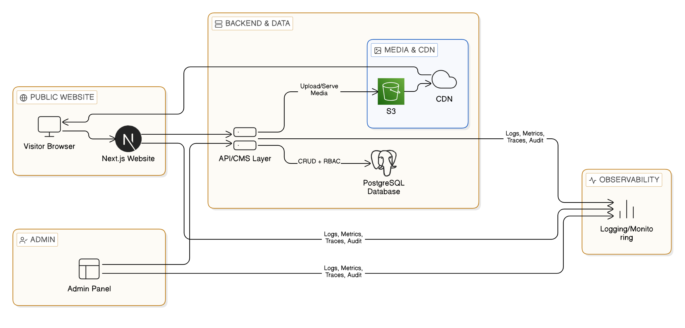.

Figure 2: CMS Content Publishing Workflow

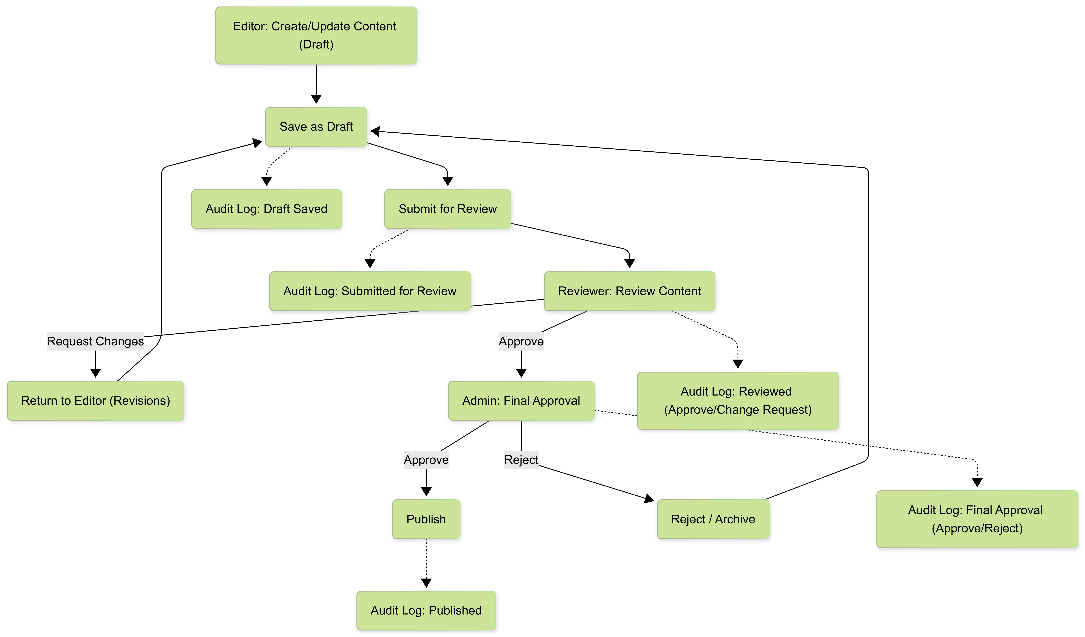

Figure 3: Admin Module & Data Model Overview (High-Level)

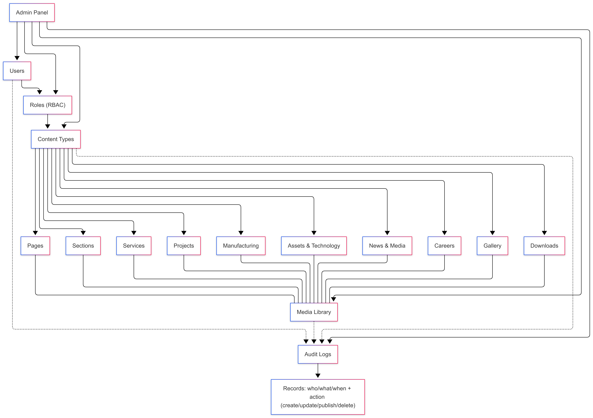

9. Assumptions & Dependencies
- Client will provide brand guidelines (logo, colors if fixed), content (text), and approval feedback within agreed review windows.
- Client will provide domain access/DNS credentials or coordinate changes with hosting provider.
- Third-party tools (analytics, captcha, email gateway) will be provided/approved by client if required.
- Content migration from an existing site is not included unless explicitly requested.

10. Acceptance, Warranty & Post-Launch Support

10.1 Warranty (Recommended)
- Warranty Period: 60 days post go-live.
- Coverage: bug fixes and minor adjustments related to delivered scope (no new features).
- Response Time: next business day acknowledgement; resolution time depends on severity (Critical/High/Medium/Low).

10.2 Post-Launch Support
- Monitoring, uptime checks, and incident response.
- Monthly security patching and dependency updates.
- Content assistance and minor enhancements (time-boxed).
- Quarterly performance and SEO health review.

11 Relevant Portfolio

HITSqwad Interactive Gaming: https://riseuplabs.com/hitsqwad/
Shopify GIS Integration: https://riseuplabs.com/shopify-gis-integration/
COMPASS: https://riseuplabs.com/compass/
Training and Learning Management System for NAEM: https://riseuplabs.com/training-and-learning-management-system-for-naem/
Teachers' Portal for Uganda: https://riseuplabs.com/teachers-portal-replication-for-uganda/
Sisimpur: https://riseuplabs.com/sisimpur/
Shanti Jewels eCommerce Website: https://riseuplabs.com/shaanti-jewels/

